Information in the City – Providing trusted information in the City
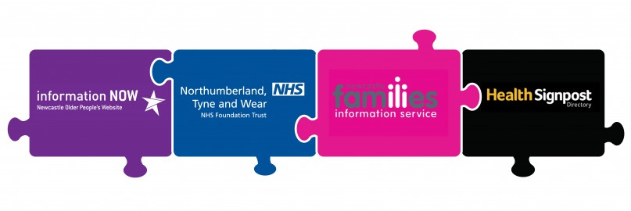
Information in the City is a partnership of 4 key information websites in Newcastle, working together to provide trusted and reliable information in Newcastle. Helping you to find useful information quickly. If you are looking for local information, advice and services relating to health, wellbeing, care and families please visit our Information in the City website partners below;
Information Now - Newcastle's Older People's information and advice website: Helping you to plan ahead, make choices and live a good quality of life.
Health Signpost Directory - Discover local groups/services who provide support, advice and activities to improve your health and well-being
Families Information Service Newcastle (FIS) - A guide to local organisations, childcare and events
Patient Information Centre - Mental health and wellbeing information including self help guides, health information in other languages and a searchable self help and support directory.

