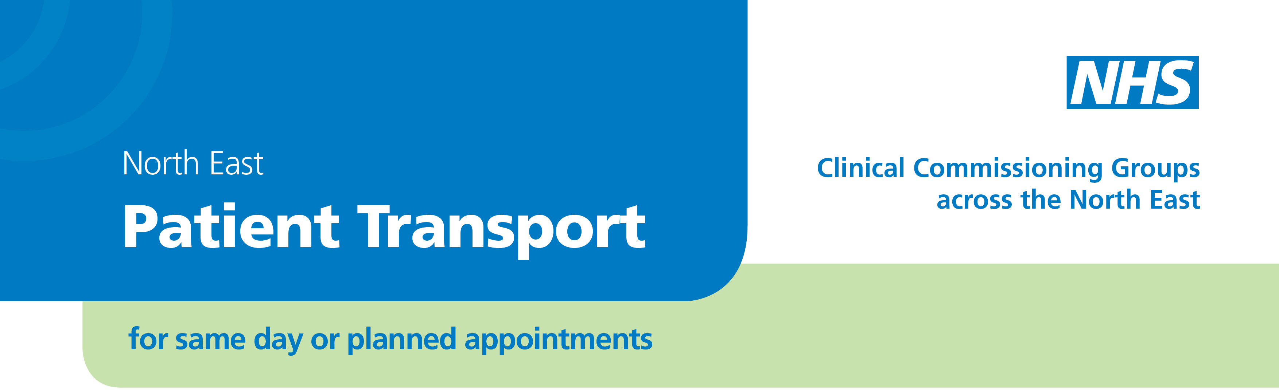

## Frequently asked questions

# Local travel information for

# Newcastle West

Information on local public transport is available from your local bus, rail and metro stations.

Newcastle City Council website, at <http://www.transportdirect.info/Web2/Home.aspx?&repeatingloop=Y> provides more detail on travel by bus in Newcastle.

## Traveline

Travel information is also available by telephone and online from the **Traveline** service, funded by local councils in the North East and Cumbria.

Call Traveline on **0871 200 22 33.** Traveline provides informationon routes and times of buses, coaches, trains, and metro, in the North East and Cumbria. The service also provides information about fares on bus, metro in North East England.

The Traveline call centre is available between 7.00am and 9 pm, available 7 days a week (except Christmas Day). A 'reduced hours' service is provided on Boxing Day and New Year's Day.

All calls are charged at 10p per minute plus any charges your network provider makes. You can also find out about journeys online: <http://jplanner.travelinenortheast.info/>

## The Red Cross

The British Red Cross can offer a drive with a vehicle providing door to door support and can provide an escort, if necessary, who can stay with you throughout your journey to your hospital appointment. They normally ask for a contribution to their costs, and mileage used.

The local office number for the Newcastle area is **0191 273 7961**

Transport requests can also be made over the internet at <http://www.redcross.org.uk/What-we-do/Health-and-social-care/Independent-living/Transport-support>

## Local Community Transport

Community transport (CT) is a term covering a wide range of transport solutions usually developed to cover a specifically identified transport need, typically run by the voluntary sector for the local community on a **not-for-profit** basis. Community transport operators aim to provide accessible transport services to people and organisations who need it.  This can mean community groups and organisations or individuals, often with specific needs, for example older people, people with disabilities, or younger people.

## The Healthcare Travel Costs Scheme

People are often concerned about the costs of getting to their appointments. You may be able to claim a refund under the 'Healthcare Travel Costs Scheme' (HTCS) of the cost of travelling to hospital or other NHS premises for NHS-funded treatment or diagnostic test arranged by a doctor or dentist.

To qualify for help with travel costs under the HTCS, you must meet three conditions:

1. At the time of your appointment, you or your partner (including civil partners) must be receiving one of the qualifying benefits or allowances, or meet the eligibility criteria of the [NHS Low Income Scheme](http://www.nhs.uk/NHSEngland/Healthcosts/Pages/nhs-low-income-scheme.aspx). <http://www.nhs.uk/NHSEngland/Healthcosts/Pages/nhs-low-income-scheme.aspx>
2. Your journey must be made to receive NHS-funded non-primary medical or non-primary dental care services, to which you have been [referred to by a GP](http://www.nhs.uk/NHSEngland/AboutNHSservices/doctors/Pages/gp-referrals.aspx), dentist or hospital consultant.
3. For referrals made by a primary practitioner such a GP or dentist, the service must be provided on a different day and in premises other than those occupied by the practitioner who made the referral.

You can claim travel costs for your children if 2 or 3 above applies to them and you are in group 1 above at the time of the appointment. Any young person aged 16 or over may make their own Local Income Scheme claim.

There is more information in [leaflet HC11- Help with health costs (PDF, 430 kb)](http://www.nhs.uk/NHSEngland/Healthcosts/Documents/hc11-april-2013.pdf) available from: <http://www.nhs.uk/nhsengland/Healthcosts/pages/Travelcosts.aspx>

## Patient Advice and Liaison Service (PALS)

The local Patient Advice & Liaison Service can give confidential advice and support and will help to sort out any concerns you may have. They are able to provide

* Advice and support to patients, their families and carers
* Information on NHS services
* Help to sort out problems quickly on your behalf and listens to your concerns, suggestions or queries.

**Freephone:** **0800 0320202** **Text: 01670 511098 Email:** [northoftynepals@nhct.nhs.uk](mailto:northoftynepals@northumbria.nhs.uk)

PALS is available Monday to Friday 9am to 4.30pm. Outside of these hours you can leave a message on an answer-machine and you will be contacted the next working day.